

**Department of Marketing**

403 Cornell Hall

Columbia, MO 65211-2600

PHONE (573) 882-3282

FAX (573) 884-0368

marketing@missouri.edu

Dear Friend of the University of Missouri,

Thank you for agreeing to sponsor a student research project for the Marketing 4050 (Marketing Research) class at the University of Missouri. This project is an important part of the students' learning experience in the course and will be one of their most memorable academic experiences from their college years. By sponsoring this project, you are playing an important role in their education, and I greatly appreciate your willingness to help in this way.

For this project, students are required to conduct a research project that will help a local business make a marketing decision or assess customer satisfaction with respect to some contemplated changes to the business. The project involves determining the scope of the research (in consultation with the sponsor), conducting a survey, and preparing a research report.

As the project proceeds, here are some things that you can expect from this group of students.

* That they will communicate with you about relevant aspects of the project during the semester, request your feedback at various stages, and submit critical elements of the project for your approval.
* They will provide you with a written report of their findings near the end of the semester in hard copy form, and an electronic version upon request.
* They will maintain the confidentiality of any sensitive information about your business that you may share with them. Please inform students if any information you discuss with them should remain confidential.
* They will act at all times in a professional manner in terms of punctuality, responsiveness, responsibility, and other normal professional business conduct.

I have taught this course for many years and have found my students to be talented, motivated, and hard working. However, please be aware that this is the first marketing research project most of them have undertaken and, as such, will not be as sophisticated as what you would expect from a professional marketing research firm.

For your part, I hope that you'll be able to do the following to help ensure the success of the project.

* Meet with the student team on several occasions throughout the semester. Most groups meet with their client in person three or four times and have additional communication by email or telephone. Meetings usually are relatively brief, except for the initial one which may last 30 minutes or more.
* Provide the students with timely responses to their questions. The project involves several strict deadlines, and students will at times need your timely feedback to meet those deadlines.
* Cover minor expenses involved in the administration of the survey, such as copy expenses. These normally would not exceed $20 or $30.
* Provide me with a written evaluation of the group's performance at the end of the semester.

If at any time you have questions about the project, please don't hesitate to contact me. It's easiest to reach me by email at richinsm@missouri.edu. You can also contact me by telephone at 882-0280.

Again, thank you for working with these students on their project. It's a big help to them, and I think that you'll also find the results of their research helpful to your business.

Sincerely,

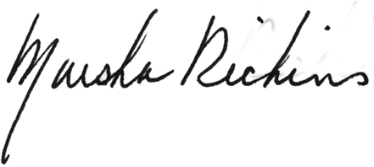

Marsha Richins

Professor of Marketing